**Instructions for Preparing Papers for 2018 IISE Asian Conference**

**Chin-Yin Huang**

Department of Industrial Engineering and Enterprise Information

Tunghai University, Taichung, Taiwan

Tel: (+886) 423594319, Email: huangcy@thu.edu.tw

**Fugee Tsung**†

Department of Industrial Engineering and Decision Analytics

Hong Kong University of Science and Technology

Clear Water Bay, Kowloon, Hong Kong

Tel: (+852) 2358 7092, Email: [season@ust.hk](mailto:season@ust.hk)

† Corresponding author

**Abstract**

All papers must include an Abstract. Begin with the word Abstract immediately following the title block with one blank line in between. Use centered, 12 point, Times New Roman Bold text for this heading. Use 10 point Times New Roman font for the text of the abstract. There should be a single blank line between the heading and this text. The abstract should be fully justified and consist of a single paragraph between 100 and 200 words (maximum of 200 words). The abstract must match the abstract submitted in XCD.

**Keywords**

Three to five keywords related to the main topic must be specified for all submissions.

## 1. Paper Size

Your paper should be formatted for A4 paper format.

## 2. Page Layout

All papers must follow the following layout:

* A4 paper
* Top and bottom margins: 1.00", left and right margins: 1.00"
* Single-spacing in a single column
* Full text justification
* No footers or page numbers
* No indentation - use a single blank line to separate paragraphs
* Maximum of 6 total pages (*including author data, references, and any figures and tables*).

## 3. Paper Title and Author Data

The following information should be placed at the top of the first page:

* Paper title: 20 point Times New Roman bold, centered
* Author listing: 12 point Times New Roman, bold, centered author names; department or college; university or company; city, state and zip, country.

## 4. Text Sections and Headings

## 4.1 Text Sections and Headings

Text should be organized into sections and subsections, with an Introduction and a Conclusions section being advisable. A single line should separate paragraphs; no indentation should be used. Font guidelines are as follows:

* Section Headings: Numbered, 12 point, bold, Upper and Lower Case, left-justified; leave one blank line above only.
* Section Sub-headings: Numbered, 10 point, bold, Upper and Lower Case, left-justified; leave one blank line above only.
* Regular text: 10 point Times New Roman, full justified, with a single line between paragraphs.

## 4.2 Bullets

Bullet guidelines are as follows:

* First level bullet.
* Second level bullet.
  + Third level bullet.

## 5. Figures, Tables, and Their Captions

Tables and figures should be included in the main text (see Figure 1 and Table 1), as close to the point of their introduction as possible. It is noted that figure and table numbering should be independent. Captions guidelines are as follows:

* Figure captions: 10 point Times New Roman, centered; place below the figure, leave one blank line above and below. For example, see Figure 1 below.
* Table caption: 10 point Times New Roman, centered; place above the table, leave one blank line above only. For example, see Table 1 below.

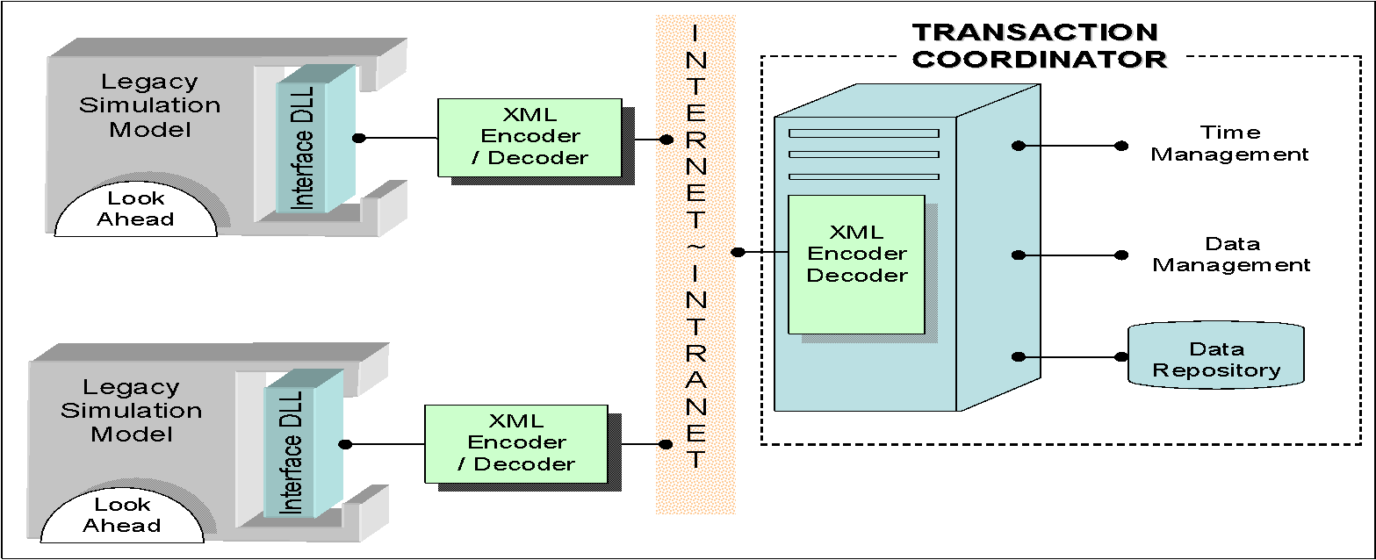

Figure 1: Example figure for demonstration

This is an example paragraph to demonstrate the guidelines for the figure and table captions.

Table 1: Example table for demonstration

|  |  |  |  |  |
| --- | --- | --- | --- | --- |
|  | | Conservative | Epoch | Improvement (%) |
| Six epochs | Federation run time | 1.1 | 0.44 | 62.8 |
| Number of time advance messages exchanged | 9470 | 1027 | 89.2 |
| Number of checking messages exchanged | 34302 | 23533 | 31.4 |

## 6. Equations

Equations should be centered and numbered, with the number in parentheses, positioned flush to the right margin. Preferably, they should be prepared with an Equation Writer. See Equation (1) below for the demonstration.

 (1)

## 7. Page Numbers

No page numbers should appear on the paper.

## Acknowledgements

Acknowledgement of funding support and/or any other kind of assistance should be contained in an "Acknowledgements" section (this section should have no section number), located immediately before the "References" section. This instruction document is a modification version of Paper Formatting Guidelines of the IISE 2018 Conference & Expo.

## References and Citations from Texts

References should be numbered sequentially by order of occurrence in the text and listed in a separate section labeled References (this section should have no section number) at the end of the document. Within the text, they should be cited by the corresponding list number, which should be enclosed in brackets [1]. If you refer to two documents, use the following format [6, 7]. If you refer to more than three documents listed consecutively, use the format [5-8]. Please follow the reference format of IISE Transactions. If Endnote is applied in the article, you can find the reference style in <http://endnote.com/styles/IIE%20Transactions.ens>

**References**

1. Kim J, Lee Y, Kim H. Detection and clustering of mixed-type defect patterns in wafer bin maps. IISE Transactions 2018; 50:99-111.
2. Ning X, Shang Y, Tsung F. Statistical process control techniques for service processes: a review. 2009 6th International Conference on Service Systems and Service Management, 2009:927-31.
3. Lincoln JR, Gerlach ML. Japan's Network Economy: Structure, Persistence, and Change. Cambridge University Press, 2004.